MANUSCRIPT SUBMISSION TEMPLATE FOR THE JOURNAL OF MEDICAL EDUCATION DEVELOPMENT: AUTHOR'S GUIDE
Title: [word style: Times New Roman, 16 Bold] Manuscript submission template: Author's guide
The title should accurately, clearly, and concisely reflect the emphasis and content of the paper. The title must be brief and grammatically correct.
Author Name¹ , Author Name² [word style: Times New Roman 11]
Please list all authors here and do not include abbreviated qualifications.
Author Name^{1,} Author Name² [word style: Times New Roman 11]
List all author affiliations in the form of department, institution, city, state, and country. For example: ‘Department of Psychiatric Nursing, School of Nursing and Midwifery, Zanjan University of Medical Sciences, Zanjan, Iran.
If two or more authors on a paper contributed equally, please use the following format:
Author name¹*
Author name²*
Author name³
*These authors contributed equally to this work.
Correspondence: [full name of the corresponding author]
[Include the full postal address here.]
Tel: [full international phone number, e.g., +1 404 234 5433]
Fax: [full international fax number]
Email:
Abstract [word style: Times New Roman 12-Bold] Please provide a brief structural summary of your article in 300 words or less. Be concise and capture the essence of your content to engage readers effectively.’
Background & Objective: [word style: Times New Roman 9 Bold]
In a concise statement, encapsulate the significance of undertaking the research and articulate the study's purpose within one or two sentences. [Word Style : Times New Roman 9]
Materials & Methods: [word style: Times New Roman 9 Bold]
The study's design, work date, sample size, sampling or participant distribution method, employed instruments, and statistical methodologies should be detailed in this section. [word style: Times New Roman 9]
Results: [word style: Times New Roman 9 Bold]
……………. [Word Style : Times New Roman 9]
Conclusion: [Word Style: Times New Roman 9 Bold]
…………… [Word Style : Times New Roman 9]
Keywords: [Word Style: Times New Roman 9 Bold]

Provide significant keywords to aid the reader in literature retrieval [word style: Times New Roman 9 in lower case]. For Example:
Keywords: nursing students, online classes, e-learning, learning style, educational challenges

Introduction [word style: Times New Roman 12-Bold]
Despite being criticized by the majority of education experts, traditional lectures are still the main training method in universities (1, 2). In addition to the fast decrease in the attention and participation of learners, the use of lectures might not be a suitable method for all students, and there might be a low level of memorization of the contents presented (3-6). [Word Style: Times New Roman 12]

Material & Methods [word style: Times New Roman 12 Bold]
The methodology should be structured based on the following items.
Design and setting(s) [word style: Times New Roman 12-Italic Bold]
……………………[word style: Times New Roman 12]
Participants and sampling [word style: Times New Roman 12 Italic and Bold]
……………………[word style: Times New Roman 12]
Tools/Instruments [word style: Times New Roman 12-Italic- Bold]
……………………[word style: Times New Roman 12]
Data collection methods [word style: Times New Roman 12-Italic- Bold]
……………………[word style: Times New Roman 12]
Data analysis [Word Style: Times New Roman 12-Italic- Bold]
……………………[word style: Times New Roman 12]

Results [word style: Times New Roman 12-Bold]

Discussion [word style: Times New Roman 12-Bold]

……………………[ word style: Times New Roman 12]

Conclusion [word style: Times New Roman 12-Bold]
……………………[word style: Times New Roman 12]
Ethical considerations [word style: Times New Roman 12- - Bold]
Emphasize the acknowledgment and dedication to ethical principles and guidelines throughout the course of the study. [word style: Times New Roman 12]
Artificial intelligence utilization for article writing [word style: Times New Roman 12- - Bold]
Emphasis on adherence to the ethical principles and guidelines of using artificial intelligence for essay writing. [word style: Times New Roman 12]

Acknowledgments [word style: Times New Roman 12-Bold]
Acknowledge any individuals or organizations that contributed to the research or manuscript but do not meet the criteria for authorship. [word style: Times New Roman 12]

Conflict of interest [word style: Times New Roman 12-Bold]

Declare any potential conflicts of interest that may exist for all authors.

Author contributions [word style: Times New Roman 12-Bold]
Briefly describe the contributions of each author to the study or manuscript.
Supporting resources [word style: Times New Roman 12-Bold]
Mention any grants, equipment, or other resources that supported the research or manuscript. [word style: Times New Roman 12]
Data availability statement [word style: Times New Roman 12-Bold]
Specify concisely whether and how the data underlying the research findings can be accessed or obtained. [word style: Times New Roman 12]
References [word style: Times New Roman 12-Bold]
Note: When mentioning the authors' names, if the number of authors is more than 6, the details of the first 3 authors are written in full, and then the phrase "et al." is mentioned.
Journals
- Gill IS, Higginson LA, Maharajh GS, Keon WJ. Do training novices to criteria and the rapid acquisition of skills on laparoscopic simulators have predictive validity, or are we just playing video games? Journal of Medical Education Development. 2021;69(2):46-51. [https://doi.org/10.1007/s002280050685]
Books
- Edelman CL, Mandle CL. Health education throughout the life span. St Louis: Mosby; 2021,163-165. [https://doi.org/10.2507/s005466050685]
Book chapters
- Philips SJ, Whisnant. Training in the field. In: Laragh JH, Brenner BM, editors. Medical education. 3rd Ed. New York: Raven Press; 2021, 78-231.
Thesis
- Kaplan SJ. Postgraduate students’ professionalism [dissertation]. St. Louis (MO): Washington University; 2021.
Accepted and in press papers (DOI number is required)
- Leshner AI. Learning process among pharmacy students: A grounded theory research study. Journal of Medcal Education Developmet. In press. [https://doi.org/10.1007/s002280050685]
Internet resources
- Norton A, Fisher B. How to train a dental student to get patient consent. East Indy Dental Care. [Online]. Available from:
https://www.nwemergencydentist.com. [Accessed: Dec. 3, 2021]. [https://doi.org/10.1007/s002280050685]

FIGURES
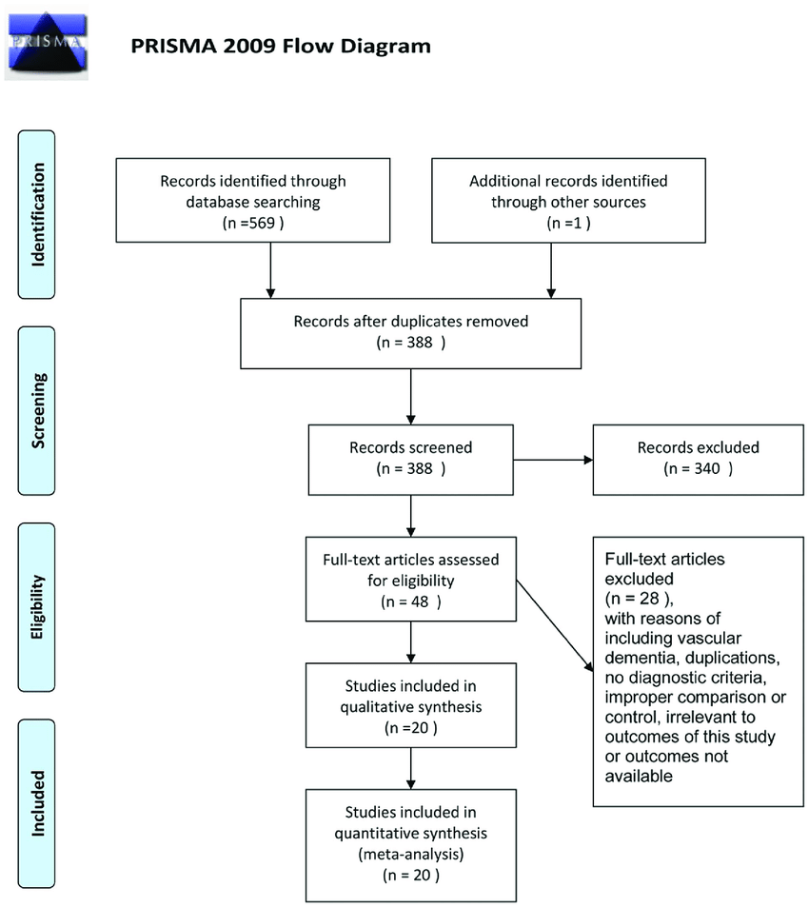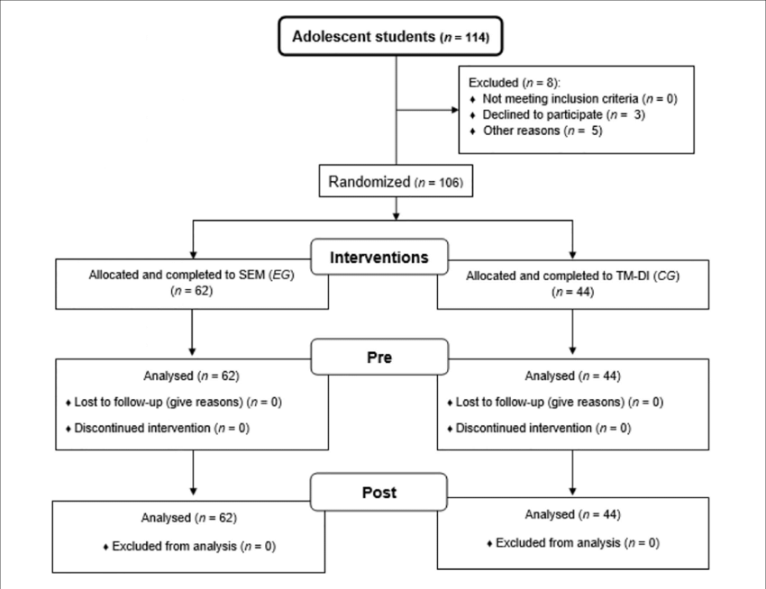
Each figure must have a caption that includes the figure number and a brief description, preferably one or two sentences. The caption should immediately follow the figure with the format “Figure 1. Figure caption.”
NOTE 1: All review and interventional studies should have a diagram to show the entry and exit of samples.
NOTE 2: Please send the figures in a separate file from the manuscript.
TABLES
Each table must feature a concise title (one phrase or sentence) describing its contents, following the format Table 1. Table Title [word style: Times New Roman 12]. Titles should be comprehensible without reference to the text, with detailed information placed in footnotes [word style: Times New Roman 10] rather than the title. Nonstandard abbreviations should be defined in footnotes. Tables [word style: Times New Roman 10]
are appropriate when data cannot be effectively presented as narrative, when presenting numerous precise numbers, or when a tabular format enhances the communication of meaningful interrelationships. Tables should prioritize simplicity and conciseness. Utilize the Table Tool in your word-processing package, entering one piece of information per cell, for optimal table generation.
Table 1 [word style: Times New Roman 12-Bold]. Relationship between learning style and demographics of basic sciences medical students [word style: Times New Roman 12]
Variables | Learning style |  |  |  | Sig.
 | Diverger | Accommodator | Assimilator | Converger
Gender n (%)
Female | 23 (21.7) | 6 (5.7) | 39 (36.8) | 38 (35.8) | X² = 0.711
Male | 27 (21.8) | 10 (8.1) | 47 (37.9) | 40 (32.3) | p = 0.871
Marital status n (%)
Single | 48 (21.4) | 15 (6.7) | 85 (37.9) | 76 (33.9) | X² = 1.924
Married | 2 (33.3) | 1 (16.7) | 1 (16.7) | 2 (33.3) | p = 0.588
Residential status n (%)
University's dormitory | 26 (26.8) | 9 (9.3) | 32 (33) | 30 (30.9)
Private dormitory | 2 (33.3) | 1 (16.7) | 1 (16.7) | 2 (33.3) | X² = 9.558
Family housing | 21 (18.6) | 6 (5.3) | 47 (41.6) | 39 (34.5) | p = 0.387
Individual housing | 1 (7.1) | 0 (0) | 6 (42.9) | 7 (50)
Age Mean ± SD | 20.90±2.97 | 20.38±1.36 | 20.16±1.43 | 20.19±1.30 | F_{(3, 226)} = 1.968  p = 0.120
GPA Mean ± SD | 16.32±2.28 | 16.06±1.85 | 16.75±1.81 | 16.66±1.30 | F_{(3, 226)} = 1.035  p = 0.378

Note [word style: Times New Roman 9-Bold]: One way ANOVA test was used to compare participants based on quantitative demographic variables of four groups. Chi-square test was employed to compare participants based on qualitative variables [word style: Times New Roman 9].
Abbreviations [word style: Times New Roman 9-Bold]: n, number of participants; SD, standard deviation; GPA, grade point average; X², Chi-square test; F, analysis of variance test; Sig, statistical significance; p, probability-value [word style: Times New Roman 9]..

